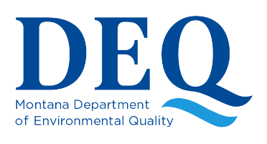
Montana Source Water Assessments
Fact Sheet SWP-201

Montana is required under provisions of the 1996 federal Safe Drinking Water Act to carry out a Source Water Assessment Program. The U.S. Environmental Protection Agency formally approved the Montana program in November 1999. The program was developed to the greatest extent possible using public participation and input from public water systems (PWSs) and other stakeholders interested in source water protection issues.

Section 1453 of the Safe Drinking Water Act (42 U.S.C. § 300j-13) requires the state program to:

Identify the source(s) of water used by PWSs
This process delineates capture zones for wells or a stream buffer area for surface water sources: the source water protection areas.

Identify and Inventory Potential Contaminant Sources
Potential significant contaminant sources within the source water protection area are identified. Regulated contaminants of concern in Montana generally include nitrate, microbial contaminants, solvents, herbicides, pesticides, and metals. Potential sources of these types of contaminants include septic systems, animal feeding operations, underground storage tanks, floor drains, sumps, and certain land use activities.

Assess the Susceptibility of the PWS to those Identified Potential Contaminant Sources
A susceptibility assessment considers the hazard rating of each potential contaminant source, identifies potential barriers to evaluate the likelihood that a spill or release would reach the well or intake, and determines the susceptibility for each identified potential contaminant source within the source water protection area.

Make the Results of the Delineation and Assessment Available to the Public
Source water assessments are made available to the public using different resources including consumer confidence reports, SWP Internet site, posting at local health departments, and others.

- Delineation and assessments are compiled into a map and text report for each PWS.
- Assistance is available for PWSs to help them utilize the delineation and assessment report to develop local source water protection plans. Participation in this part of the program remains voluntary.
- The program is applicable to all public water systems

This program may be important to you:
If you are a public water system, it means that you will receive a technical report describing your water source(s).
If you are a property or business owner engaged in activities regulated by DEQ and located near a PWS, you may be identified on a map provided to the PWS. This map is intended to encourage communication and cooperation between the PWS and those that may impact the water resource.
If you are a consultant working on environmental issues, you may find opportunities to connect this program to your existing work.
If you are a user of a public water system, you benefit from this program as the reports make information about your water supply readily available to you.

Resources:
For more information, contact the Montana Source Water Protection Program at (406) 444-5546; or go to https://deq.mt.gov/water/Programs/dw-sourcewater

